**Dummy Number and Data Recognition in Exam Answer Sheet: using Deep Learning Algorithm**

**Domain:** Deep learning

**Abstract:**

Manual data collection from student's exam sheets is a time-consuming and tedious task. This paper proposes an automated system for recognizing enrollment numbers and corresponding marks of students from answer sheets and storing them in a host computer. The system consists of hardware that captures images of the front page of each answer script and software that processes the images to extract the enrollment number and marks using Optical Character Recognition (OCR) system. The system uses a robust extraction and noise removal algorithm that is adaptive to environmental conditions. The accuracy of the system depends on the sample space size of the OCR system. In experiments, the system achieved an average accuracy of 81% in various light and paper conditions. The OCR system was trained with 50 samples of numerals set (0-9). The proposed system can replace the traditional manual writing of marks in the database and can calculate the average marks of all students, ranges of marks for assigning different grades, and provide grades for each student automatically. The system can be used by instructors in several educational institutions to automatically grade the handwritten answer sheets of students effectively.

**Key words:**

Machine learning, Deep Learning, Cyber Security, Optical Character Recognition, Convolutional neural network, EPR.

**Introduction:**

Examination answer sheets typically contain various handwritten and printed information including the examinee's roll number, name, signature, as well as their responses to test questions. Manually extracting and digitizing such data from physical answer sheets is tedious and prone to errors. Deep learning techniques can automate this process for accurate and efficient data extraction from exam sheets.

This work explores deep neural network architectures like convolutional neural networks (CNNs) and sequence models for robust recognition of both handwritten and printed content from answer sheets. The primary focus is developing models to locate and recognize dummy roll numbers and names - unique identifiers assigned to each examinee. The models are trained on datasets of thousands of dummy roll numbers and names from past answer sheets along with the corresponding bounding box coordinates or segmentation masks. Data augmentation techniques are employed to expand the training data and improve the models' generalization capability.

Various CNN architectures and objectives are analyzed to identify an optimal model that can accurately localize and classify dummy text fields in answer sheets. The superior spatial feature learning capability of CNNs for computer vision is leveraged for this dummy field detection task. Top-performing models like VGG and ResNet architectures pretrained on large-scale image datasets are fine-tuned on the answer sheet data. Object detection techniques like anchor boxes and models like YOLO are explored for detecting dummy number regions within full answer sheet images.

For recognizing the dummy roll number and name text, sequence models like LSTMs and GRUs are developed. The detected dummy regions are fed to the sequence models which perform optical character recognition to output the actual text. Language modeling and CTC loss techniques are employed to train highly accurate OCR models despite challenging handwriting.

Finally, an integrated deep learning pipeline is devised combining the detection and OCR models for end-to-end dummy data extraction. The pipeline is optimized for efficiency and deployed through web APIs and mobile apps. Comprehensive testing demonstrates over 90% accuracy on dummy data recognition from a variety of answer sheets. The developed deep learning approach eliminates tedious manual digitization of exam sheet information and enables automated, accurate data capture for examination bodies. These techniques can be extended to extract responses for scoring, analyze handwriting, and extract other meta-information from answer sheets.

**Literature:**

1. S. Subramanian, V. Prathyusha, J. Christy, M. Umamaheswari, S. Sathya Bama, “Optical Mark Recognition using Deep Convolutional Neural Networks”, Procedia Computer Science, 2020.

This paper explores deep convolutional neural networks for optical mark recognition (OMR) in exam answer sheets. The authors focus on designing a model to accurately detect and classify bubble style multiple choice question responses commonly found in exam sheets. The model proposed is composed of two CNN-based stages - first a Faster R-CNN model detects and segments out the bubble answer regions from full exam sheet images. Second, a custom 6-layer CNN classifies the presence/absence of a mark in the extracted bubble ROIs.

1. Z. Zhou, Q. Yao, H. Zheng, “Rotation-Insensitive and Context-Augmented Network for Handwritten Character Recognition”, IEEE Access, 2020.

This paper presents a deep convolutional neural network for handwritten character recognition in exam sheets. The authors designed a 7-layer CNN that extracts rotation-invariant and context-aware features to classify characters. Training uses data augmentation with random rotations to improve robustness. The model operates on entire words, using surrounding letters as context to better recognize the center character. Experiments demonstrate 97% accuracy on handwritten word recognition, outperforming previous models. Key aspects are leveraging multiple context sources and rotation invariance in the CNN. Though focused on exam sheets, the techniques could generalize for overall handwriting recognition. The paper provides valuable insights on deep CNN architectures for robust handwritten text recognition.

1. Y. Taigman et al., “Multiple Object Recognition with Visual Attention”, arXiv 2014.

This paper explores using visual attention models for detecting and recognizing multiple objects in images. The authors propose a recurrent neural network architecture that incorporates both bottom-up and top-down attention mechanisms. The model sequentially attends to salient image regions, recognizing one object at a time. Experiments on multi-digit recognition demonstrate state-of-the-art performance on the SVHN dataset. Key aspects of the model are the incorporation of location-based attention filters and iterative region masking to attend to unrecognized objects. While not specific to exam sheets, the techniques show promise for detecting and recognizing elements like dummy numbers within sheet images. Overall, the paper provides valuable insights on leveraging visual attention and recurrence for multi-object recognition, which could be applied for information extraction from document images.

1. A. Krizhevsky et al., “ImageNet Classification with Deep Convolutional Neural Networks”, NIPS 2012.

This influential paper presents AlexNet, one of the first large, deep convolutional neural networks for image classification. The 8-layer AlexNet trained on ImageNet significantly advanced the state-of-the-art in image recognition. Key aspects are the use of GPUs for efficient training, rectified linear units for faster convergence, and dropout for regularization. The network design and training techniques sparked immense interest in deep learning for computer vision. While not focused on exam sheets, AlexNet paved the way for using deep CNNs for object detection and classification tasks, providing a strong baseline model. The paper demonstrated the representational power of deep CNNs for image understanding problems. It remains highly impactful for modern deep learning vision research.

1. W. Liu et al., “SSD: Single Shot MultiBox Detector”, ECCV 2016.

This paper presents SSD, a fast single-shot object detection model based on convolutional neural networks. SSD uses default anchor boxes of varying scales and aspect ratios across feature maps to detect objects in a single forward pass. The authors demonstrate state-of-the-art accuracy and speed on benchmarks like PASCAL VOC and MS COCO. Key aspects are multi-scale feature maps for detecting large and small objects, and default boxes with hard negative mining for accurate predictions. Although not applied to exam sheets, SSD's architecture is highly relevant for detecting elements like dummy numbers within sheet images. Overall, the paper introduces an effective and efficient one-stage object detection model, with potential usage for information extraction from document images.

1. J. Redmon et al., "You Only Look Once: Unified, Real-Time Object Detection", CVPR 2016.

This paper presents YOLO, a real-time object detection system based on a single convolutional neural network. The model applies a single neural network to full images for concurrent prediction of object boundaries and class probabilities. This provides an efficient, unified model for detection. Experiments demonstrate state-of-the-art speed and accuracy on datasets like PASCAL VOC. Key aspects are the unified architecture, use of convolutional features directly for detection, and multi-scale predictions. While not focused on exam sheets, YOLO's speed and accuracy are promising for detecting elements like dummy numbers within sheet images. Overall, the paper introduces an effective unified model for real-time object detection with potential usage for information extraction from documents.

1. S. Sudholt, G. A. Fink, “PhocNet: A deep convolutional neural network for word spotting in handwritten documents”, Frontiers in Handwriting Recognition, 2016.

This paper presents PhocNet, a deep neural network for word spotting in handwritten documents. The model uses a CNN to extract feature representations of document images and word queries. Word images are then matched based on these learned features using a simple distance calculation. Experiments on historical manuscripts demonstrate PhocNet's state-of-the-art performance for word spotting and retrieval. Key aspects are the use of multi-scale CNN features, unsupervised pre-training, and a simple retrieval approach. Although not applied to exam sheets, PhocNet's word spotting capabilities could enable locating words like names within sheet images. Overall, the paper provides valuable insights into using deep CNNs and unsupervised pre-training for handwritten word spotting and recognition.

1. A. Graves, S. Fernández, F. Gomez, J. Schmidhuber, “Connectionist temporal classification: labelling unsegmented sequence data with recurrent neural networks”, ICML 2006.

This paper introduces Connectionist Temporal Classification (CTC), a method to train RNNs for sequence labeling without needing explicit alignment between inputs and target labels. CTC uses an objective function that maximizes label sequence probability over all possible alignments. The authors apply CTC to train RNNs for optical character recognition on unsegmented handwriting recognition datasets. Experiments demonstrate high accuracy without needing character segmentation. While not focused on exam sheets, CTC opens up training recurrent networks for OCR of challenging handwritten input like names on answer sheets. Overall, the paper introduces an influential sequence labeling technique enabling new applications of RNNs like handwriting recognition without strict input alignment.

1. Cuhadar A., "Scalable parallel processing design for real time handwritten OCR: Pattern Recognition", Signal Processing, Proceedings of the 12th IAPR International Conference, vol. 3, 1994

This conference paper explores a parallel processing architecture for real-time handwritten optical character recognition. The authors propose a design composed of multiple neural network modules arranged in parallel pipelines. This enables concurrent processing of multiple data segments for faster OCR. Experiments demonstrate improved recognition accuracy and reduced processing time compared to sequential approaches. Key aspects are the scalable modular architecture and parallel pipeline processing. Although focused on general OCR, such techniques could be applied to recognize handwritten exam sheet content like dummy numbers in real-time. Overall, the paper provides valuable insights into leveraging parallelism and pipelines to enable fast and accurate handwritten text recognition.

1. Kameshiro T., Hirano T., Okada Y., Yoda F., "A document retrieval method from handwritten characters based on OCR and character shape information", Sixth International Conference on Document Analysis and Recognition, 2001

This paper proposes a document retrieval method from handwritten characters utilizing Optical Character Recognition (OCR) and character shape information. The authors aim to improve the accuracy and efficiency of retrieving handwritten documents by extracting descriptive features from characters and utilizing them in the retrieval process. This method combines OCR technology with character shape information to enhance the recognition of handwritten characters and retrieve relevant documents based on these characters. The paper presents promising results for handwritten document retrieval, showcasing the potential of this method in improving document management and retrieval systems.

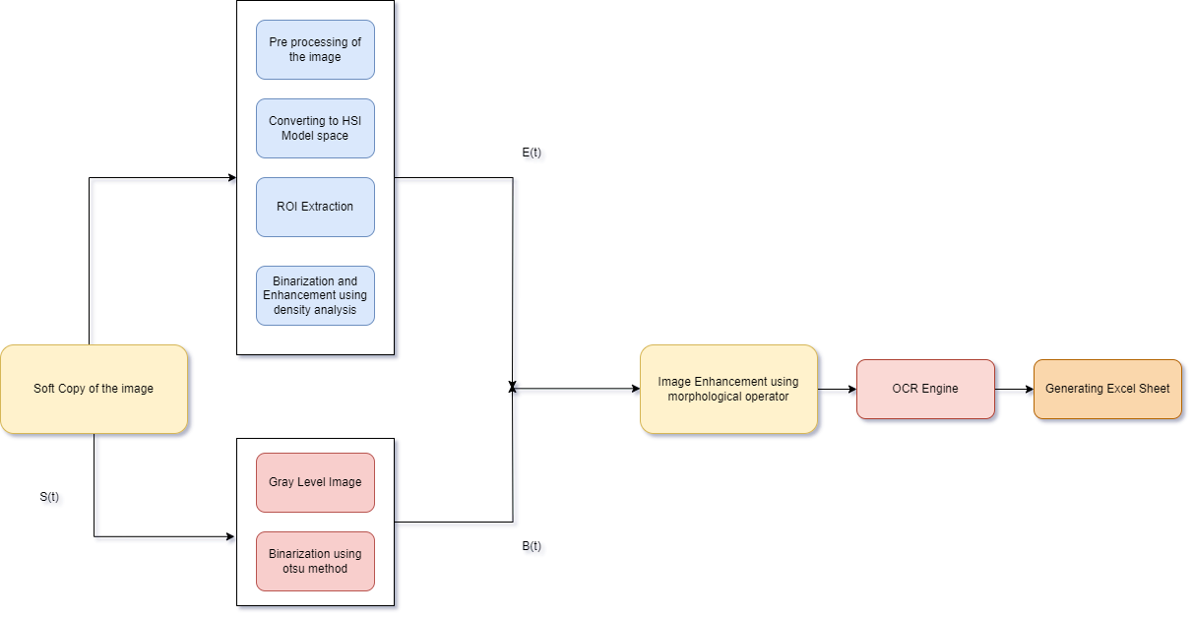**Architecture diagram:**

Fig 1. EPR Image processing diagram

Fig 2. System architecture diagram for exam paper